**MODULE-1(Fundamental)**

**QUE:-1 What is SDLC?**

SDLC meaning is “**SOFTWARE DEVLOPMENT LIFE CYCLE.”**

SDLC focuses on the following phases of software development. In this cycle has seven stages.

1. PLANING
2. ANALYSIS
3. DESIGN
4. BUILD(IMPLEMENTION/CODING)
5. TESTING
6. DEPLOY
7. MAINTAIN.

**QUE:-2 WHAT IS SRS?**

SRS is the **“SOFTWARE REQUIRMENTS SPECIFICAION.”**

SRSis a document that describes what the software will do and how it will be expected to perform. SRS forms the basis of an organization’s entire project.

**QUE-3 WHAT IS AGILE METHODOLOGY?**

AGILE METHODOLOGY IS THE VERY FASTEST METHOLOGY. Agile is an iterative approach to project management and software development that helps teams deliver value to their customers faster. In the Agile methodology functionality can be developed rapidly. It is suitable for fixed or changing requirements.

**QUE:-4 EXPLAIN PHASES OF THE WATERFALL MODEL?**

WATERFALL MODEL IS THE VERY SIMPLE ANDIDEALISTIC.

Waterfall methodology focuses very little on the end user or client involved with a project. Waterfall model is used for smaller projects. In the waterfall mode does not go to previous phase after next phase. Waterfall model is very easy to work in modulus. In this phase requirements are very well documented, clear and fixed. This project is very short.

**QUE:-5 WRITE PHASES OF SPIRAL MODEL.**

The spiral model has four phases: **Planning, Design, Construct, and Evaluation**. In this model,we can easily change requirements at later phases and incorporated accurately. It is good for large and complex projects.

**QUE:-6 WRITE SDLC PHASES WITH BASIC INTRODUCTION.**

SDLC meaning is “**SOFTWARE DEVLOPMENT LIFE CYCLE.”**

In this cycle has seven stages.

1. PLANING
2. ANALYSIS
3. DESIGN
4. BUILD(IMPLEMENTION/CODING)
5. TESTING
6. DEPLOY
7. MAINTAIN.

* **PLANNING:-**This phase is the most fundamental in the SDLC process. The planning phase of the SDLC is also when the project plan is developed that identifies, prioritizes, and assigns the tasks and resources required to build the structure for a project.
* **ANALYSIS:-**This crucial phase is where project members dive deep and define the technical requirements of the system so they can be properly addressed. This documents describes what is to be built.
* **DESIGN:-**In this phase, software design documents are prepared as per the requirements specification document. In this phase documents divide two phase: 1. HIGH LEVEL DESIGN(HLD)

2. LOW LEVEL DESIGN(LLD)

* **BUILD(IMPLEMENTION/CODING):-**Once the system design phase is over the next phase is build. In this phase, developers start build the entire system by writing code using the chosen programming language. This phase is longest phase of the software development life cycle process.
* **Testing:-**In general testing is finding out how well something works. The testing phase of the SDLC help companies to identity all the bugs and errors in the software before the implementation phase begins. Software testing is the process of evaluating and verifying that a software product or application does what it is supposed to do.
* **DEPLOY:-SDLC DEPLOYEMENT PHASE** provides for production installation and customer acceptance for the software, requiring all test cases to verify successful software completeness and correctness.
* **MAINTAIN:-**After the software clears all the SDLC phases without any issues, then it goes into the maintenance stage. The maintenances phase of the SDLC occurs after the product is in full operation.

**QUE:-7 WHAT IS OOPS?**

OOPS is the “OBJECT-ORIENTED PROGRAMMING.”

OOPS is a programming paradigm based on the concept of “objects.”

**OOPS CONCEPTS:-**

1. Object
2. Class
3. Encapsulation
4. Inheritance
5. Polymorphism
6. Abstraction

**QUE:-8 WRITE THE BASIC CONCEPTS OF OOPS?**

According, the oops there are six concepts of OOPS

Like,

**OOPS CONCEPTS:-**

1. Object
2. Class
3. Encapsulation
4. Inheritance
5. Polymorphism
6. Abstraction

**QUE:-9 WHAT IS OBJECT?**

Object is the using the concept of two things. like property method and data functionality. Object is just be like things, person, place, process. An object is a single instance of a class.

**QUE:-10 WHAT IS CLASS?**

A Class is a user defined type that describes what a certain type of object will look like. A class is a blueprint that defines the variables and the methods common to all objects of a certain kind.

**QUE:-11 WHAT IS ENCAPSULATION?**

Encapsulation is the idea of bundling data and methods that work on that data within one unit. Encapsulation benefits to hiding information about attributes and methods using encapsulation in programming is that it prevents other developers from writing scripts that using your code.

**QUE:-12 WHAT IS INHERITANCE?**

Inheritance is the two types of class which is “Super class” and “Sub class.” Inheritance allows us to define new classes by extending existing classes. The new class inherits all the behavior of the original class.

Inheritance is the many types like:

* SINGLE INHERITANCE
* MULTIPAL INHERITANCE
* HIERARCHICAL INHERITANCE
* MULTILEVEL INHERITANCE
* HYBND INHERITANCE

**QUE:-13 WHAT IS RDMS?**

**RDBMS IS “RELATIONAL DATABASE MANAGEMENT SYSTEM”.**

RDBMS is a database management system that is based on the relational model. The RDBMS provides an interface between users and applications and the database, as well as administrative functions for managing data storage, access and performance.

**QUE:-14 WHAT IS SQL?**

SQL is Structured Query Language, which is a computer language for storing, manipulating and retrieving data stored in relational database. SQL is the standard language for relation database system.

**QUE:-15 WRITE SQL COMMANDS.**

SQL HAVE 4 COMMANDS:-

* **DDL:- DATA DEFINATION LANGUAGE** 1.CREATE 2.ALTER 3.DROP
* **DML:- DATA MANIPULATION LANGUAGE** 1.INSERT 2.UPDATE 3.DELETE
* **DCL:-DATA CONTROL LANGUAGE** 1. GRANT 2.REVOKE
* **DQL:- DATA QUERY LANGUAGE**

1. SELECT

**QUE:-16 WHAT IS JOIN?**

A JOIN IS CLAUSES IS USED TO COMBINE ROWS FROM TWO OR MORE TABLES, BASED ON A RELATED COLUMN BETWEEN THEM.

SQL Server supports many kinds of different joins including INNER JOIN, LEFT JOIN, RIGHT JOIN and FULL OVER JOIN.

**QUE:-17WRITE TYPES OF JOIN.**

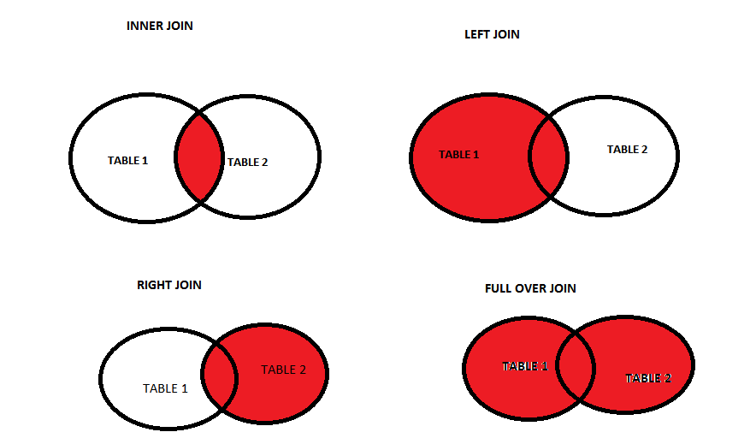

**QUE :- 18 DRAW USECASE ON ONLINE BOOK SHOPPING**

**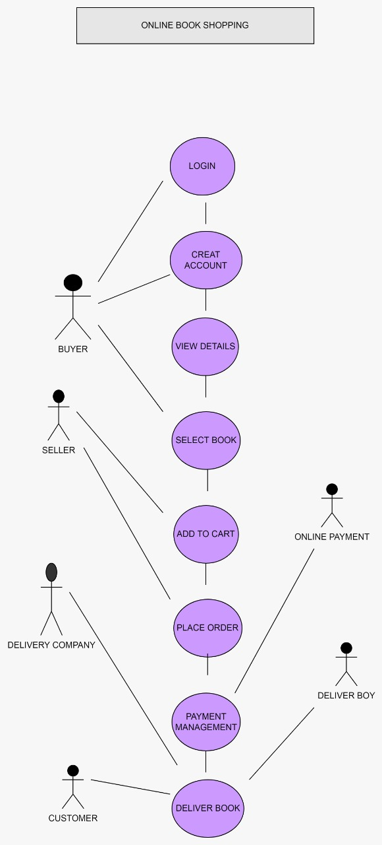  
QUE :- 19 DRAW USECASE ON ONLINE SHOPPING PRODUCT USING PAYMENT GATEWAY.**

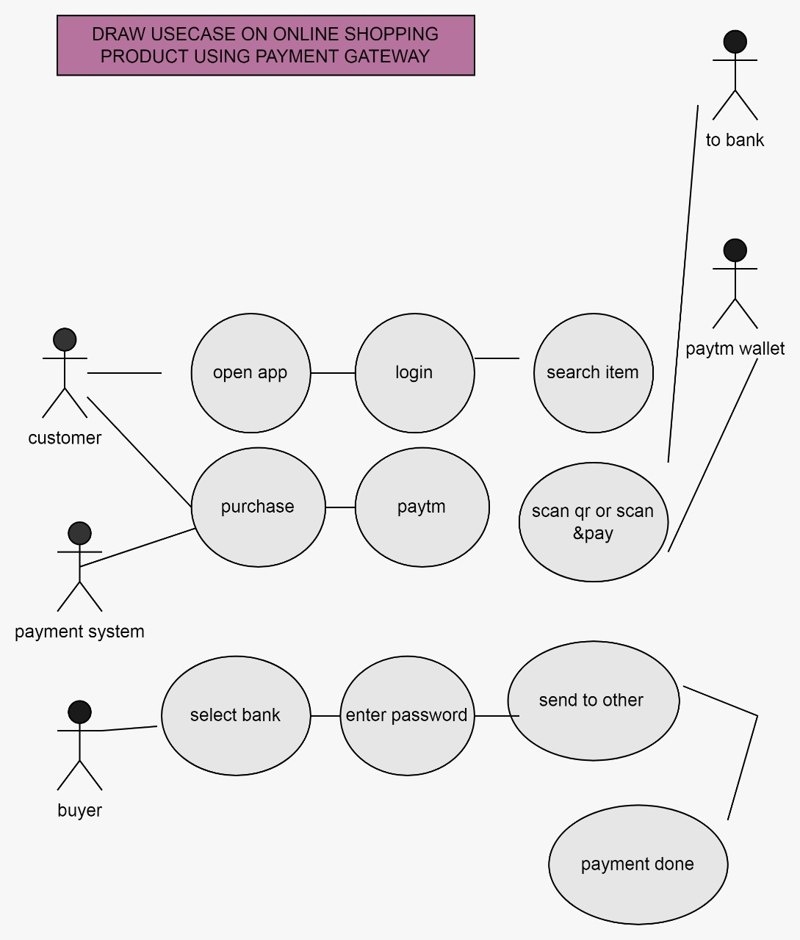

**QUE :- 20 WHAT IS POLYMORPHISM?**

Software polymorphism is a process in which provision of a single interface to entities of different type or the use of single symbol to represent multiple different types.

**QUE :- 21 WRITE AGILE MANIFESTO PRINCIPLES.**

**AGILE MANIFESTO PRINCIPLES ARE:-**

* Satisfying customers through early and continuous delivery of valuable work.
* Measuring process by the amount of completed work.
* Maintaining a constant pace of completed work.
* Welcoming changing requirements, even late in a project.
* Minimal rules, documentation easily employed.
* Functionality can be developed rapidly and demonstrated.

**QUE :- 22 DRAW USECASE ON ONLINE BILL PAYMENT SYSTEM(PAYTM).**

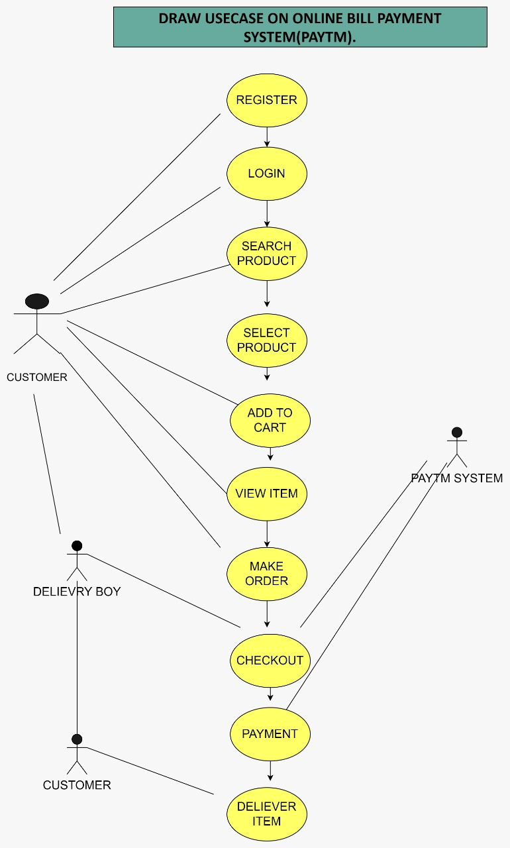

**QUE :- 22 DRAW USECASE ON ONLINE SHOPPING PRODUCT USING PAYMENT GATEWAY.**

